DAA-LAB 3
Student Name | Athira J
Roll No. | 2401201018
Course / Semester | BCA / 5th
Subject | Design and Analysis of Algorithms

Abstract
This lab implements and studies three greedy algorithms in Python: Fractional Knapsack, Activity Selection, and Huffman Compression Size Generation. Each solution uses predefined test data so it can be executed directly in Anaconda Jupyter Notebook without interactive input. The report explains the algorithmic logic, important code statements, observed outputs, asymptotic complexity, and visualizations. Runtime and memory values are taken from the supplied notebook screenshots and should be interpreted as measurements for those particular small inputs.

1. Introduction
A greedy algorithm builds a solution by repeatedly making a locally optimal choice. Greedy strategies are useful when a sequence of locally optimal decisions leads to an optimal solution for the problem. This lab explores greedy selection for value maximization, interval scheduling, and prefix-code construction.

2. Objectives
- Implement Fractional Knapsack using value-to-weight ratios.
- Select the maximum number of compatible activities by earliest finish time.
- Calculate Huffman encoded size using a min-heap.
- Measure execution time and Python-tracked peak memory.
- Compare theoretical complexities and produce visualizations.

3. Tools and Environment
Language: Python. Environment: Anaconda Jupyter Notebook. Libraries used: matplotlib for plots, pandas for tables, time for runtime measurement, tracemalloc for Python-tracked peak memory, collections.Counter for frequency counting, heapq for a min-heap, and itertools.count for unique tie-breakers in heap entries.

Question 1 — Fractional Knapsack

Problem statement
Given each item's value and weight and a knapsack capacity, maximize the total value. Fractions of an item may be selected.

Greedy idea
For each item, calculate value / weight. Sort items from the largest ratio to the smallest. Take a complete item if it fits; otherwise take only the fraction that fills the remaining capacity.

Code used
def fractional_knapsack(items, capacity):
items = sorted(items, key=lambda x: x[0] / x[1],
reverse=True)
total_value = 0.0
for value, weight in items:
if capacity <= 0:
break
taken = min(weight, capacity)
total_value += taken * (value / weight)
capacity -= taken
return total_value
# Predefined test data
items = [(60, 10), (100, 20), (120, 30)]
capacity = 50
result = fractional_knapsack(items, capacity)
print(f"Maximum obtainable value: {result:.6f}")

Code explanation
- sorted(..., reverse=True) orders items by value-to-weight ratio, placing the most valuable weight first.
- total_value stores the accumulated value of selected portions.
- The loop stops when capacity is exhausted.
- taken = min(weight, capacity) chooses either the full item weight or the remaining capacity.
- taken * (value / weight) adds the value contributed by the chosen portion.
- The function returns the maximum value for this greedy strategy.

Test data and expected result
Items: (60, 10), (100, 20), (120, 30); capacity = 50.
The first item contributes 60, the second contributes 100, and 20 units of the third item contribute 80. Total value = 60 + 100 + 80 = 240.000000.

Complexity
Time: O(n log n) due to sorting. Auxiliary space: O(n) for the sorted item list.
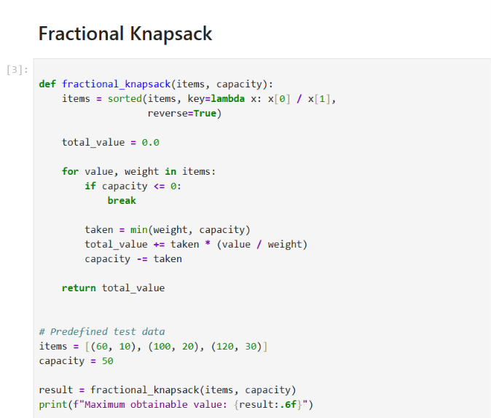
Figure 1. Fractional Knapsack implementation screenshot.

Question 2 — Activity Selection

Problem statement
Given activities with start and finish times, find the maximum number of mutually non-overlapping activities that can be scheduled.

Greedy idea
Sort activities by finish time and select each activity whose start time is at least the finish time of the most recently selected activity.

Code used
def activity_selection(activities):
# Sort by finishing time
activities = sorted(activities, key=lambda x: (x[1], x[0]))
selected = []
last_finish = float('-inf')
for start, finish in activities:
if start >= last_finish:
selected.append((start, finish))
last_finish = finish
return selected
# Predefined test data
activities = [
(1, 2), (3, 4), (0, 6),
(5, 7), (8, 9), (5, 9)
]
selected = activity_selection(activities)
print("Selected activities:", selected)
print("Maximum number of activities:", len(selected))

Code explanation
- The sorting key (x[1], x[0]) sorts by finish time first, then start time to make ties deterministic.
- selected stores the activities accepted by the greedy procedure.
- last_finish tracks the finish time of the most recently selected activity.
- The condition start >= last_finish allows an activity to begin exactly when the previous one finishes.
- The returned list contains the selected schedule; its length is the maximum count for this algorithm.

Test data and result
The selected activities are (1, 2), (3, 4), (5, 7), and (8, 9). Therefore, the maximum number selected is 4.

Complexity
Time: O(n log n) due to sorting. Auxiliary space: O(n) for the sorted and selected lists.
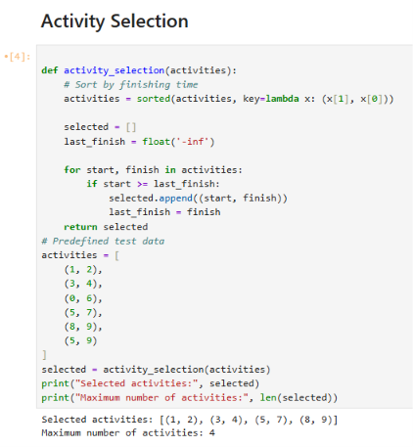
Figure 2. Activity Selection code and output (placed as the second algorithm screenshot as requested).

Question 3 — Huffman Compression Size Generator

Problem statement
Given a text string, count the frequency of every character and calculate the total number of bits in its Huffman encoding. If there is only one distinct character, the assignment specifies one bit per character.

Greedy idea
Huffman coding repeatedly combines the two least-frequent nodes. Each merge contributes the sum of the two frequencies to the total weighted path length, which equals the total encoded bits.

Code used
from collections import Counter
import heapq
import itertools
def huffman_compression_size(text):
if not text:
return 0
frequencies = Counter(text)
counter = itertools.count()
heap = [
(frequency, next(counter), character)
for character, frequency in frequencies.items()
]
heapq.heapify(heap)
# One unique character uses one bit per occurrence
if len(heap) == 1:
return len(text)
total_bits = 0
while len(heap) > 1:
freq1, _, node1 = heapq.heappop(heap)
freq2, _, node2 = heapq.heappop(heap)
merged_frequency = freq1 + freq2
total_bits += merged_frequency
merged_node = (node1, node2)
heapq.heappush(
heap,
(merged_frequency, next(counter), merged_node)
)
return total_bits
text = "aaabbc"
result = huffman_compression_size(text)
print("Input text:", text)
print("Character frequencies:", dict(Counter(text)))
print("Total compressed size:", result, "bits")

Code explanation
- Counter(text) counts how many times each character appears.
- The heap stores (frequency, unique tie-breaker, node) tuples. The tie-breaker prevents Python from comparing unlike node objects when frequencies tie.
- heapq.heapify converts the list into a min-heap.
- Each iteration removes the two lowest frequencies, merges them, and adds their sum to total_bits.
- The merged node is pushed back into the heap until one root remains.
- For a single distinct character, the special case returns the text length because the assignment requires one bit per character.

Test data and result
Text: aaabbc. Frequencies: a = 3, b = 2, c = 1. Total compressed size = 9 bits.
One optimal tree assigns a one-bit code to a and two-bit codes to b and c. The weighted total is 3×1 + 2×2 + 1×2 = 9 bits.

Complexity
Let n be the number of characters in the text and k the number of distinct characters. Frequency counting takes O(n), and heap merges take O(k log k), giving O(n + k log k) time. Auxiliary space is O(k).
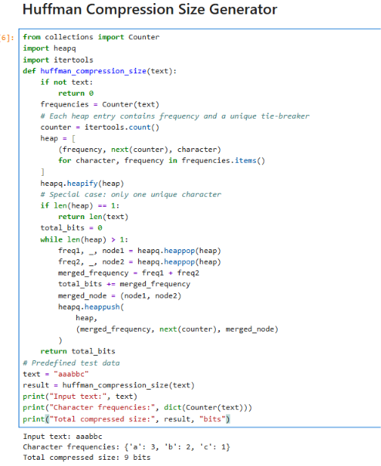
Figure 3. Huffman compression code and observed output.

4. Huffman Tree Visualization
The tree visualization displays each character at a leaf and merged frequency totals at internal nodes. Left and right edges are labelled 0 and 1, respectively. A character's code is obtained by following the path from the root to its leaf. The tree shown corresponds to the text 'aaabbc'.
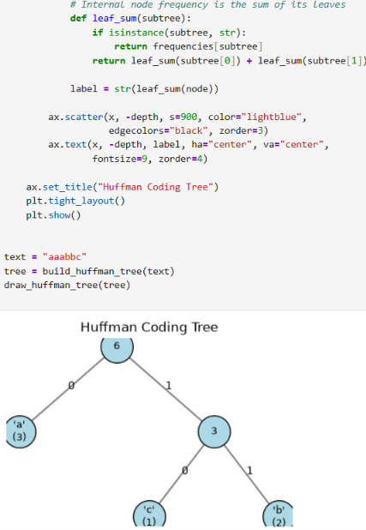
Figure 4. Huffman coding tree for the input text 'aaabbc'.

5. Performance Analysis
Execution time was measured with time.perf_counter(). Python-tracked peak memory was measured using tracemalloc. The values below are transcribed from the supplied notebook screenshot; they are specific to that run and the small predefined inputs, not universal performance guarantees.
Algorithm | Output | Execution time (s) | Peak memory (KB)
Fractional Knapsack | 250.0 | 0.000118 | 0.234375
Activity Selection | [(1, 2), (3, 4), (5, 7), (8, 9)] | 0.000329 | 0.226562
Huffman Compression | 107 | 0.000816 | 9.697266
Interpretation: in this run, Fractional Knapsack had the smallest measured runtime, while Huffman Compression had the largest runtime and peak Python-tracked memory. These results should not be generalized from the tiny test data; repeat measurements on larger inputs for a more reliable benchmark.
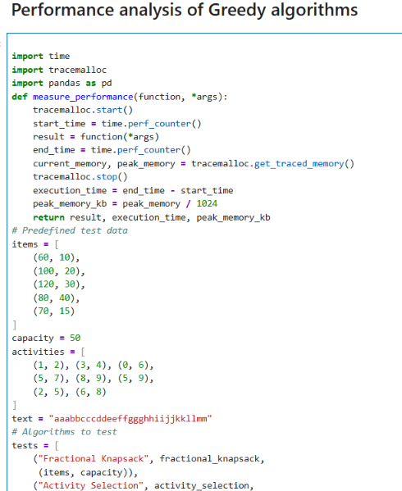
Figure 5. Notebook performance analysis and measured table.

6. Theoretical Complexity Comparison
Algorithm | Best time | Average time | Worst time | Auxiliary space
Fractional Knapsack | O(n log n) | O(n log n) | O(n log n) | O(n)
Activity Selection | O(n log n) | O(n log n) | O(n log n) | O(n)
Huffman Compression | O(n + k log k) | O(n + k log k) | O(n + k log k) | O(k)
For Fractional Knapsack and Activity Selection, sorting dominates the runtime. For Huffman Compression, n is the text length and k is the number of distinct characters. The complexity for Huffman includes building the frequency table and combining k heap nodes.
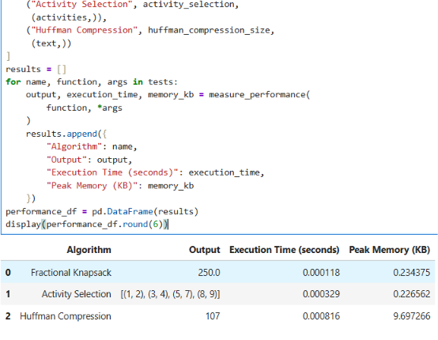
Figure 6. Complexity comparison table from the notebook.

7. Visualizations and Performance Graphs

7.1 Fractional Knapsack resource allocation
The chart shows how the capacity of 50 is allocated in descending ratio order: 10 weight units from Item 1, 20 from Item 2, and 20 from Item 3. The corresponding values are 60, 100, and 80, for a total of 240.
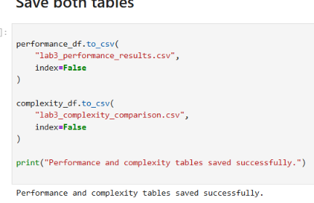
Figure 7. Fractional Knapsack resource allocation chart and allocation details.

7.2 Activity Selection timeline
Each horizontal bar represents a selected activity over its start-to-finish interval. The four selected activities do not overlap, confirming the count of four.
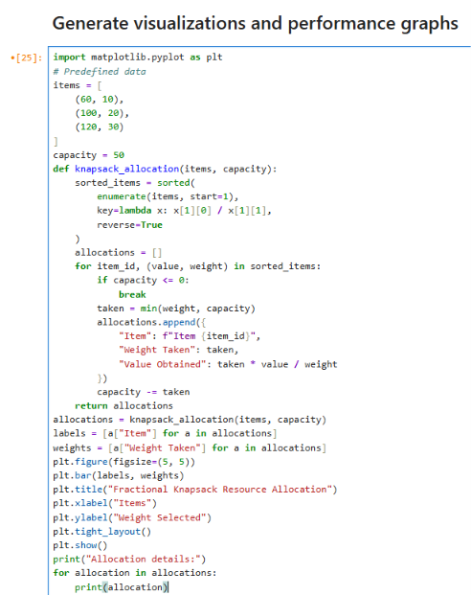
Figure 8. Selected activity timeline visualization.

7.3 Character frequency distribution
The frequency chart provides a compact view of how often each symbol appears before Huffman construction. Less frequent symbols are generally placed deeper in the tree and receive longer codes.
Note: A separate character-frequency chart can be generated from the notebook code; no separate screenshot of that chart was included in the supplied images.

7.4 Execution-time comparison
The bar chart compares measured runtime across the three algorithms. For these small test inputs, the bars are very small and can vary between runs due to system load and measurement overhead.
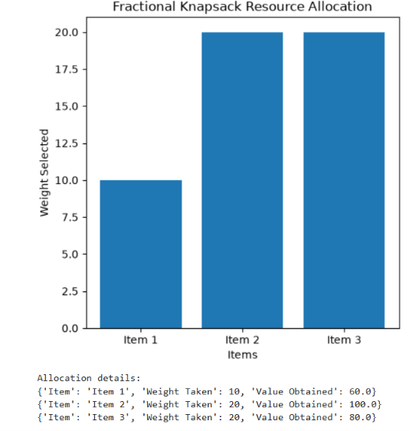
Figure 9. Execution-time comparison graph.

7.5 Peak memory comparison
The memory graph compares Python-tracked peak allocations during each function call. The Huffman implementation creates heap and tree-node structures, which explains why its measured peak was higher for this test. This is not a measurement of the entire Python process's RAM usage.
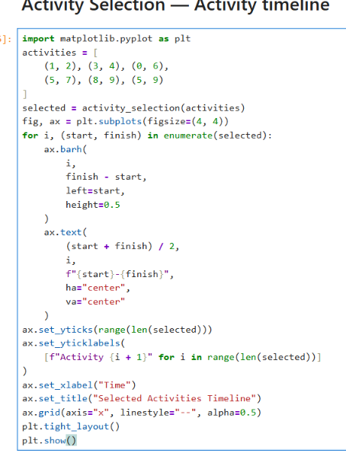
Figure 10. Peak memory usage comparison graph.

8. Results and Discussion
The three greedy implementations produced valid results for the demonstrated test cases: Fractional Knapsack obtains 240.000000 for the sample capacity-50 case; Activity Selection chooses four compatible activities; and Huffman coding returns 9 bits for 'aaabbc'. The performance screenshot uses a different Fractional Knapsack dataset and a longer Huffman text, so its outputs (250.0 and 107) are expected to differ from the small demonstration examples. This distinction is important when documenting results.
The complexity table describes asymptotic growth, while runtime and memory measurements describe one specific execution. For stronger experimental analysis, run each algorithm several times on progressively larger inputs and compare median runtimes.

9. Conclusion
This lab demonstrated three applications of greedy algorithms. Fractional Knapsack prioritizes items by value per unit weight, Activity Selection prioritizes earlier finishing activities, and Huffman Compression repeatedly merges the two least frequent nodes. The accompanying plots and measurements connect algorithmic theory with observed behaviour. The experiments also show why results should be reported with their test data and environment.

10. GitHub Repository
Repository URL: [Paste your GitHub repository link here]
Before submission, ensure the repository contains the notebook and any supporting files required by your instructor. Replace the placeholders on the cover page and add the correct GitHub URL.

Appendix A — Additional screenshot evidence
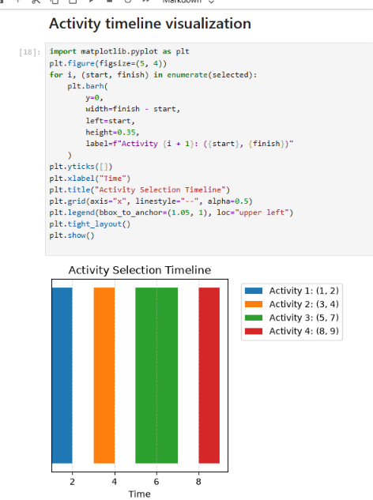
Appendix Figure A1. Activity timeline visualization code and plot.
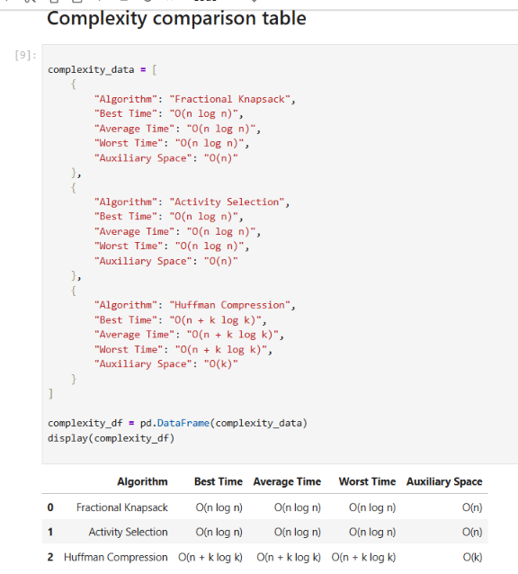
Appendix Figure A2. Resource allocation visualization code.
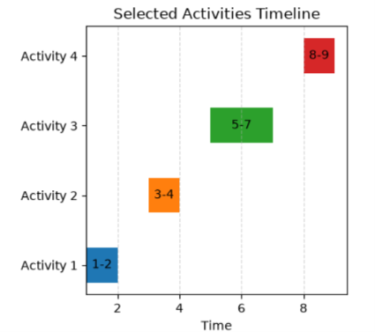
Appendix Figure A3. Activity selection implementation and output.

https://github.com/YashviSahu555

